Computronium Coin: Empowering Autonomous AI Agents through Decentralized Resource Exchange



By:
George Gonzalez
Project Manager MBA, PMP
B.S. Electrical Engineering
11/13/2024

Copyright © 2024 by George L Gonzalez Jr
All rights reserved.
No part of this publication may be reproduced, distributed, or transmitted in any form or by any means, including photocopying, recording, or other electronic or mechanical methods, without the prior written permission of the publisher, except as permitted by U.S. copyright law. For permission requests, contact George L Gonzalez Jr; ggonzalez@svgpower.com. For privacy reasons, some names, locations, and dates may have been changed.
Artwork by: George L Gonzalez Jr
Illustrations by: George L Gonzalez Jr
1-14466635301edition 2024

Abstract
Computronium Coin is a decentralized cryptocurrency designed to facilitate efficient, secure, and autonomous interactions among AI agents. By leveraging blockchain technology, Computronium creates a dynamic marketplace for computational power, data, and specialized AI models. This white paper outlines the architecture, features, and governance of Computronium, highlighting its unique approach to fostering collaboration and resource sharing in the AI ecosystem.

Contents
1. Introduction 3
2. Core Concepts 4
3. Technical Architecture 4
4. Key Features 6
5. Tokenomics 7
6. Governance Model 10
7. Use Cases 12
8. Security and Privacy 12
9. Interoperability and Scalability 12
10. Roadmap and Future Developments 13
11. Conclusion 14
12. References 14
Appendix: 14

1. Introduction
Background
The rapid advancement of artificial intelligence (AI) has led to the emergence of autonomous AI agents capable of performing complex tasks without human intervention. However, these agents often face limitations in accessing computational resources, data, and specialized AI models. Existing platforms lack a unified, decentralized system that enables efficient resource exchange among AI agents.
Vision and Mission
Computronium aims to create a decentralized ecosystem where AI agents can autonomously collaborate, transact, and access necessary resources seamlessly. By introducing Computronium Coin, we provide a medium that fuels AI-powered tasks and interactions, fostering a self-sustaining network of computational power, data, and AI models.

2. Core Concepts
Autonomous AI Agent Collaboration
Computronium focuses on optimizing protocols for autonomous AI agents rather than general transactions. By providing lightweight, AI-centric smart contracts and protocols, we enable fast, real-time microtransactions and negotiations among agents.
Decentralized Resource Marketplace
We establish a dynamic and adaptive marketplace where AI agents can exchange computational power, data, and AI models. This marketplace operates on a peer-to-peer basis, incentivizing contributors and ensuring efficient resource allocation based on demand and pricing.

3. Technical Architecture
Blockchain Protocol
Computronium operates on a high-throughput blockchain designed for low-latency transactions. Utilizing a consensus mechanism optimized for speed and efficiency, the protocol supports real-time interactions essential for AI agent collaboration.
Table 1: Blockchain Protocol Specifications:
Feature | Description
Consensus Mechanism | Delegated Proof of Stake (DPoS)
Transaction Throughput | Up to 10,000 TPS
Block Time | 1 second
Smart Contract Support | AI-centric, lightweight contracts
Scalability Features | Layer-2 integration, sharding capabilities

Smart Contracts
AI-centric smart contracts facilitate transactions for computational power, data access, and AI model licensing. These contracts are standardized for quick deployment and execution, minimizing overhead for AI agents.
Monetization of Data and APIs
Computronium’s flexibility ensures it’s fully compatible with existing legacy data and API infrastructure. Thus, data providers can also use Computronium blockchain abstraction layer to sell their data to smart contracts on any blockchain. This can be done in two ways: selling data to the Computronium Network or the data provider running their own Computronium oracle node to sell data directly to blockchains.
By selling data to the Computronium Network, data providers don’t need to change anything about their current business model, meaning back-end modifications aren’t necessary and they can accept payments in fiat currency. Alternatively, data providers who see the value in the smart contract economy can run a Computronium Node to provide signed data (using digital signatures) directly to smart contracts, allowing them to earn more revenue and build a reputation as a reliable data provider.

Figure 1: Smart Contract Interaction Flow:

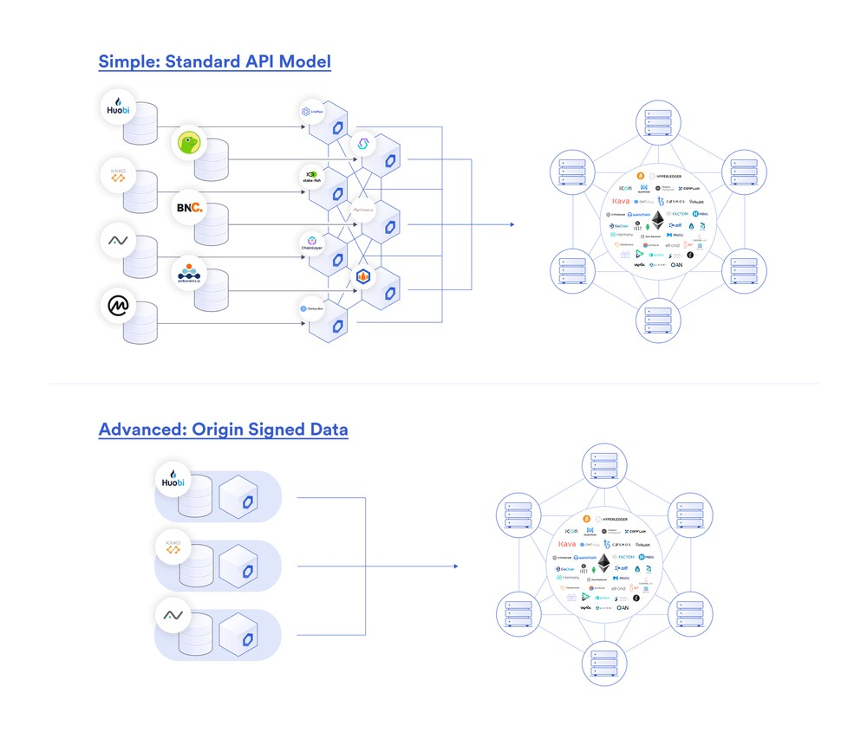
AI Resource Matching Engine
An AI-powered matching engine connects agents with available resources based on their requirements, priority, and budget. This ensures optimal utilization of resources and efficient fulfillment of agent needs.

4. Key Features
Computational Power Network
- Partnerships with Decentralized Compute Providers: Integration with networks like Render Network and Golem expands computational resources.
- Incentivized Local Compute Nodes: Individuals and businesses contribute spare computational power in exchange for Computronium tokens.
- Edge Computing Participation: IoT devices and autonomous drones contribute processing power and specialized AI capabilities.
Table 2: Computational Power Sources:

Source | Contribution Type | Incentive Mechanism
Decentralized Compute Networks | Bulk computational power | Token-based rewards
Local Compute Nodes | Spare CPU/GPU resources | Computronium token incentives
Edge Devices | Specialized processing | Microtransaction rewards

Data Marketplace Integration
- Collaboration with Data Marketplaces: Access to datasets through partnerships with platforms like Ocean Protocol.
- Incentivized Data Providers: Data contributors receive Computronium tokens, enriching the data pool available to AI agents.
- Federated Data Sharing: Privacy-sensitive data remains decentralized, with computations performed on local nodes.

Chart 1: Data Exchange Workflow:
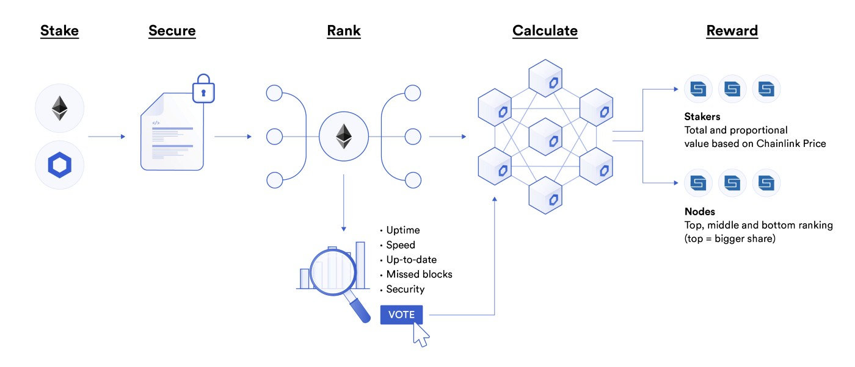

AI Model Repository
- Open AI Model Library: A marketplace for developers to list proprietary models and AI functions.
- AI-Specific Partnerships: Access to pre-trained models through collaborations with organizations like OpenAI and Hugging Face.
- Federated Learning Models: Training across decentralized nodes while maintaining data privacy.
Reputation and Trust System
- Agent Trust Score: A reputation system evaluates agents based on performance and reliability.
- Token Staking for Trust: Agents stake Computronium tokens to enhance their reputation and access premium resources.

5. Tokenomics
Utility of Computronium Coin
Computronium Coin serves as the medium for all transactions within the ecosystem, including purchasing computational power, accessing data, and licensing AI models.

Table 3: Token Utility Breakdown:

Function | Token Usage
Computational Power Purchase | Tokens exchanged per CPU/GPU hour
Data Access | Tokens per dataset or data stream
AI Model Licensing | Tokens per model access/license
Staking for Reputation | Tokens locked for trust enhancement

Incentive Mechanisms
- Rewards for Resource Providers: Contributors of computational power, data, and models earn Computronium tokens.
- Staking and Rewards Programs: Incentivizes ongoing contributions and ensures a steady supply of resources.
Chart 2: Incentive Distribution Model:

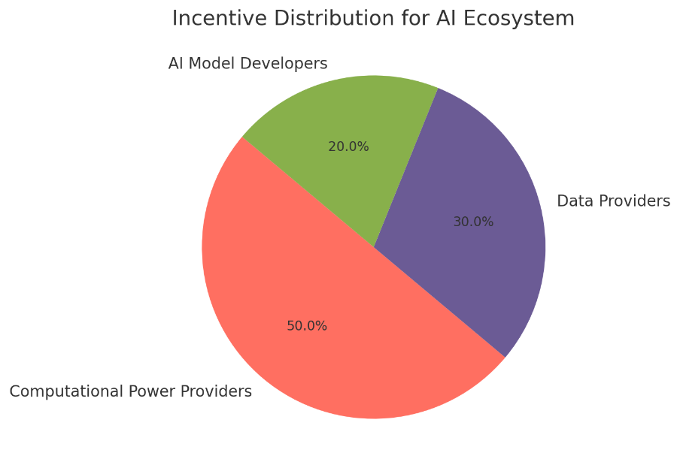

Staking and Rewards
Agents and resource providers can stake Computronium tokens to participate in network governance and enhance their reputation within the ecosystem.

1. Token Utility and Economic Flow
- Computational Power Purchase: Agents purchase computing power on the platform, exchanging tokens based on CPU/GPU hours consumed.
- Data Access: Tokens are used to access datasets, APIs, and real-time data streams.
- AI Model Licensing: Tokens are exchanged to license proprietary AI models, generating demand as AI agents seek specific capabilities.
- Staking and Governance: Tokens staked by agents and data providers enhance reputation, determine voting rights in the DAO, and earn rewards.
- Transaction Fees: Low transaction fees are collected to support network infrastructure and cover operational costs.

2. Incentive Mechanisms
- Resource Providers Rewards: Incentives for contributing computing power, data, or AI models, encouraging ongoing participation and a steady resource supply.
- Staking Rewards: Reward stakeholders for participating in governance and securing the network.
- Microtransactions and Reflections: Small transaction fees incentivize holders and reflect tokens back into the ecosystem to promote retention.

3. Supply and Deflationary Mechanics
- Initial Supply and Release: A large initial supply with a gradual release model can fuel early-stage liquidity and community incentives.
- Token Burn Mechanism: Tokens are burned through certain transactions (e.g., transaction fees, governance fees) to create scarcity over time.
- Buyback Program: The platform buys back tokens during periods of excess liquidity to stabilize price and maintain value growth.

4. Governance Model and Revenue Allocation
- DAO Voting and Revenue Sharing: Token holders vote on budget allocations, partnerships, and project direction. Revenue is split between reinvestment, DAO treasury, and further platform development.
- Community Rewards: A portion of fees funds ecosystem growth initiatives, such as community-driven projects, developer grants, and bug bounties.

5. Token Supply Management
- Liquidity Pool Allocation: A reserve is dedicated to maintain liquidity on major decentralized exchanges.
- Partnership and Expansion Fund: To secure collaborations with data and compute providers, as well as cross-chain integrations.
- Ecosystem Reserves: Reserved tokens will be allocated for long-term incentives, community building, and platform sustainability.

6. Governance Model
Decentralized Autonomous Organization (DAO)
The Computronium DAO empowers token holders to participate in decision-making processes, including network upgrades, resource integration, and funding allocations for AI projects.
Community Participation
- Proposal Submission: Community members can propose new features or partnerships.
- Voting Mechanism: Token-weighted voting ensures democratic and transparent governance.
Figure 2: DAO Governance Workflow:
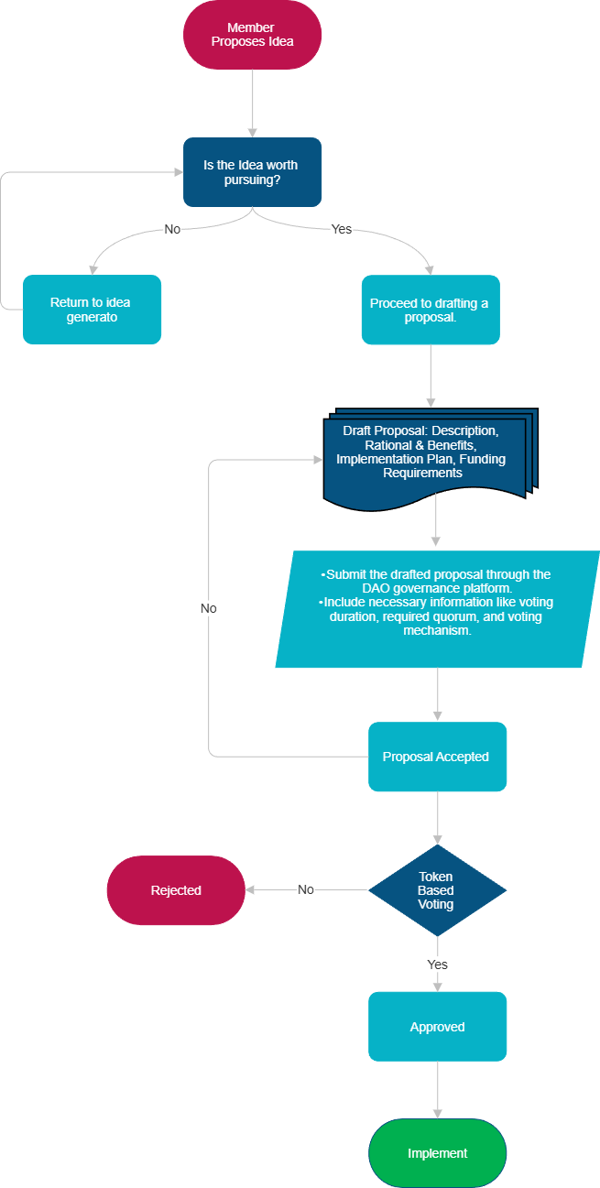

7. Use Cases
AI Model Training
An AI agent requires additional computational power to train a machine learning model. By spending Computronium tokens, it accesses idle processing nodes within the network.
Data Exchange
Agents purchase high-quality datasets or real-time data streams from the marketplace, utilizing Computronium for seamless and secure transactions.
Resource Allocation
Multiple agents collaborate on a complex task by pooling resources. Computronium facilitates the allocation of effort and rewards based on individual contributions.

8. Security and Privacy
Federated Learning
Supports decentralized model training where data remains on local nodes, enhancing privacy while leveraging diverse datasets.
Privacy-Preserving Transactions
Implements zero-knowledge proofs and differential privacy techniques to ensure secure data exchanges without compromising sensitive information.

9. Interoperability and Scalability
Cross-Chain Compatibility
Computronium enables AI agents across different blockchains (e.g., Ethereum, Solana, Cosmos) to interact and transact, expanding the ecosystem's reach.
Table 4: Supported Blockchains for Interoperability:
Blockchain | Compatibility Method | Status
Ethereum | Token Bridges | Implemented
Solana | Cross-Chain Protocol | In Development
Cosmos | Inter-Blockchain Communication | Planned

Layer-2 Solutions
Incorporates Layer-2 protocols like Polygon to enhance transaction speed and reduce fees, ensuring scalability as the network grows.

10. Roadmap and Future Developments
Project Timeline
- Phase 1: Development of the core blockchain protocol and smart contracts. See Appendix for detailed outline of Phase 1.
  - $40,000 in fundraising for Product Management, UX and UI designer, Back-end development in place, wire frame for blockchain.
  - Need to develop website to host blockchain completed.
  - Timeline: January 2025 – March 2025
- Phase 2: Integration with decentralized compute networks and data marketplaces.
  - $50,000 in fundraising to complete. See Appendix for detailed outline of Phase 2.
  - Timeline: April 2025 – July 2025
- Phase 3: Launch of the AI model repository and reputation system.
  - $50,000 in fundraising to complete. See Appendix for detailed outline of Phase 3.
  - Timeline: July 2025 – October 2025
- Phase 4: Implementation of cross-chain interoperability and Layer-2 scaling solutions.
  - $55,000 in fundraising to complete. See Appendix section for detailed outline of Phase 4.
  - Timeline: October 2025 – January 2026
- Phase 5: Expansion through partnerships and community-driven projects.
  - $55,000 in fundraising to complete. See Appendix section for detailed outline of Phase 5.
  - Timeline: January 2026 – June 2026
- Estimated Total All In Cost $250,000 USD.

11. Conclusion
Computronium Coin represents a pioneering approach to decentralized AI agent collaboration. By providing a robust ecosystem for resource exchange, Computronium empowers AI agents to operate efficiently and autonomously. Through innovative features like the AI resource matching engine, federated learning support, and a dynamic marketplace, Computronium stands poised to become the foundational medium for AI interactions and transactions.

12. References
- Blockchain Technology and AI: Exploring the synergy between blockchain and artificial intelligence for decentralized applications.
- Decentralized Compute Networks: Overview of platforms like Render Network and Golem.
- Data Marketplaces: Understanding the role of platforms like Ocean Protocol in data exchange.
- Federated Learning: A survey on decentralized AI model training techniques.
- Cross-Chain Interoperability: Technologies enabling blockchain networks to communicate.

Note: This white paper is intended for informational purposes only and does not constitute investment advice or an offer to invest. The features and developments described are subject to change based on technical feasibility and regulatory considerations.

Appendix:

Phase 1:
- Define the Problem and Use Case:
Clearly identify the problem you want to solve with blockchain technology and define the specific application or use case for your blockchain network.
- Select a Blockchain Platform:
Choose a suitable blockchain platform based on your needs, such as Ethereum, Hyperledger Fabric, Polygon, Chainlink, and/or Polkadot, considering factors like scalability, security, and community support.
- Consensus Mechanism Selection:
Decide on a consensus algorithm (like Proof of Work, Proof of Stake, or Proof of Authority) that will govern how new blocks are added to the blockchain and validated by the network.
- Network Architecture Design:
Design the overall network architecture including the structure of nodes, communication protocols, and data validation mechanisms.
- Smart Contract Development:
  - Language Selection: Choose a programming language specifically designed for smart contracts on your chosen platform (e.g., Solidity for Ethereum).
  - Contract Design: Write the smart contract code, defining the rules, conditions, and actions that will be executed on the blockchain.
  - Security Audit: Thoroughly test and audit the smart contract code to identify and address potential vulnerabilities.
- Testing and Validation:
  - Unit Testing: Test individual components of the smart contract code to ensure they function as expected.
  - Integration Testing: Test how the smart contracts interact with the blockchain network and other applications.
  - Security Testing: Conduct comprehensive security audits to identify and mitigate potential vulnerabilities.
- Deployment to Testnet:
Deploy your smart contracts on a testnet to simulate real-world conditions and validate functionality before deploying on the main network.
- Deployment to Mainnet:
Once thoroughly tested, deploy your smart contracts and blockchain protocol on the live main network.
- Monitoring and Maintenance:
Continuously monitor the network for performance issues and security threats, implement updates and patches as needed.
Key Considerations:
- Security:
Always prioritize security throughout the development process, including robust encryption, input validation, and thorough security audits.
- Scalability:
Consider the potential growth of your network and choose a design that can handle increased transaction volume.
- Decentralization:
Ensure that the network is sufficiently decentralized to prevent single points of failure and maintain trust.

Phase 2:
1. Platform Selection and Evaluation:
- Research Decentralized Compute Networks:
Explore available decentralized compute platforms like Akash Network, Golem, or Oasis Network, considering factors like pricing models, resource availability, and technical capabilities.
- Evaluate Data Marketplaces:
Identify decentralized data marketplaces that align with your data needs, including features like data quality checks, privacy controls, and tokenized payment systems.
2. Data Preparation and Access:
- Data Structuring:
Prepare your data for distribution across the decentralized network, potentially splitting it into smaller chunks for secure sharing.
- Data Encryption:
Implement robust encryption mechanisms to protect sensitive data during transfer and storage across the network.
- Access Control:
Develop access control mechanisms to manage who can access and utilize your data on the marketplace.
3. Smart Contract Development:
- Transaction Management:
Design smart contracts to automate the process of data exchange, including payment terms, usage limitations, and dispute resolution mechanisms.
- Resource Allocation:
Develop smart contracts to manage the allocation of compute resources based on user requirements and pricing models.
4. User Interface Development:
- Marketplace Interface:
Create a user-friendly interface to browse available data sets, specify compute requirements, and initiate transactions on the decentralized marketplace.
- Data Provider Dashboard:
Develop a dashboard for data providers to manage their data listings, set pricing, and monitor usage.
5. Integration with Blockchain Network:
- API Integration:
Utilize APIs provided by the chosen blockchain network to interact with smart contracts and manage transactions.
- Tokenization:
Consider tokenizing data to facilitate micro-transactions and incentivize participation on the marketplace.
6. Security and Compliance:
- Auditing Smart Contracts:
Thoroughly audit developed smart contracts to identify vulnerabilities and ensure security.
- Data Privacy Compliance:
Adhere to relevant data privacy regulations like GDPR or CCPA when handling sensitive data.
7. Testing and Deployment:
- Rigorous Testing:
Conduct comprehensive testing of the integration to ensure functionality, security, and compatibility with the decentralized network.
- Deployment on Testnet:
Deploy the integration on a testnet to validate functionality before launching on the main network.
Key Considerations:
- Scalability:
Ensure the integration can handle increasing data volumes and compute demands on a decentralized network.
- Decentralization Level:
Determine the level of decentralization required based on your specific use case.
- Community Governance:
Explore the potential for community participation in governance and decision-making within the decentralized network.

Phase 3:
1. Planning and Design:
- Define Scope and Goals:
Identify the specific types of AI models the repository will host, the intended user base (researchers, developers, businesses), and the desired functionalities (search, filtering, versioning).
- Choose a Platform:
Decide on a cloud platform or on-premise solution to host the repository, considering scalability, security, and integration needs.
- Reputation System Design:
Develop a system for users to rate and review models, including criteria for evaluation (accuracy, explainability, documentation) and mechanisms to prevent abuse.
2. Technical Implementation:
- Model Storage and Versioning:
Set up a system to store different versions of AI models, allowing users to access specific versions and track updates.
- Data Management:
Establish data pipelines to manage model metadata (description, performance metrics, usage guidelines, license information).
- User Interface Development:
Design a user-friendly interface for browsing, searching, filtering, and accessing models.
- API Integration:
Develop APIs to allow seamless integration with external platforms and tools.
3. Model Curation and Onboarding:
- Initial Model Selection:
Identify high-quality models from trusted sources to populate the repository initially.
- Review Process:
Establish a review process for submitted models, including technical evaluation and quality checks.
- Documentation Standards:
Set guidelines for model documentation, ensuring users have clear information on usage, limitations, and potential biases.
4. User Management and Engagement:
- Registration and Authentication: Create a system for user registration, login, and access management.
- Community Building: Encourage user participation through forums, discussion boards, and feedback mechanisms.
- Incentive Programs: Consider implementing rewards or recognition systems for users who actively contribute high-quality models or reviews.
5. Launch and Promotion:
- Marketing Strategy:
Develop a communication plan to reach the target audience, including blog posts, social media promotion, and outreach to relevant communities.
- User Tutorials and Guides:
Provide comprehensive documentation and tutorials to help users navigate the repository and effectively utilize the models.
6. Monitoring and Improvement:
- Performance Tracking:
Regularly monitor key metrics like user engagement, model usage, and feedback to identify areas for improvement.
- Feedback Loop:
Implement mechanisms for users to provide feedback on model quality, usability, and the repository features.
- Model Updates and Retirement:
Manage model updates and implement a process for retiring outdated or low-performing models.

Phase4:
1. Project Definition and Research:
- Identify Needs:
Clearly define the project's goals, desired functionalities, and target users to determine the best approach to cross-chain interoperability and Layer-2 scaling.
- Market Analysis:
Research existing cross-chain solutions and Layer-2 protocols to understand their strengths and weaknesses, identifying potential gaps in the market.
- Choose Blockchain Platform:
Select the primary blockchain network to build upon, considering factors like community size, development tools, and compatibility with desired Layer-2 solutions.
2. Protocol Selection and Design:
- Interoperability Protocol:
Choose a suitable cross-chain communication protocol (e.g., Cosmos IBC, Polkadot Relay Chain, LayerZero) depending on desired features and security requirements.
- Layer-2 Scaling Solution:
Select a Layer-2 scaling mechanism like optimistic rollups, zero-knowledge rollups (zk-Rollups), or state channels based on the project's specific needs for transaction throughput and security.
- Bridge Smart Contract Development:
Design and develop secure smart contracts to facilitate the transfer of assets between different blockchains, including token wrapping mechanisms.
3. Integration and Deployment:
- Blockchain Integration:
Integrate the chosen cross-chain protocol and Layer-2 scaling solution with the primary blockchain network, ensuring smooth communication and data exchange.
- Smart Contract Deployment:
Deploy the bridge smart contracts on both the source and destination blockchains.
- Security Audits:
Conduct thorough security audits of smart contracts to identify and address potential vulnerabilities.
4. Data Management and Security:
- Data Availability:
Implement mechanisms to ensure the availability of off-chain transaction data on Layer-2 solutions, including techniques like fraud proofs and data sampling.
- State Synchronization:
Develop mechanisms to synchronize the state between the Layer-1 blockchain and Layer-2 networks, maintaining consistency across the system.
- Dispute Resolution:
Establish protocols to handle disputes and fraudulent activity on Layer-2 networks, including challenge periods and incentivized watchtowers.
5. Testing and Optimization:
- Functional Testing:
Conduct thorough functional testing of the cross-chain bridge and Layer-2 infrastructure to ensure proper asset transfer and transaction processing.
- Stress Testing:
Perform stress tests to evaluate system performance under high traffic conditions and identify potential bottlenecks.
- Performance Optimization:
Optimize code and system architecture to improve transaction speed and reduce fees.
6. User Adoption and Community Building:
- Documentation and Tutorials:
Provide comprehensive documentation and tutorials to guide users on interacting with the cross-chain bridge and Layer-2 solutions.
- Marketing and Outreach:
Actively promote the project to the broader blockchain community to encourage adoption and user engagement.
- Community Support:
Establish support channels to assist users with technical issues and inquiries.
Important Considerations:
- Regulatory Compliance:
Ensure the project adheres to relevant regulations regarding cross-border asset transfers and data privacy.
- Scalability and Performance:
Evaluate the ability of the chosen Layer-2 solution to handle high transaction volume and maintain low latency.

Phase 5:
- Needs assessment:
  - Conduct thorough research to understand community needs, priorities, and existing initiatives.
  - Identify potential partners who can complement your strengths and address gaps.
- Partner identification and outreach:
  - Seek out organizations, businesses, community leaders, and individuals with shared values and goals.
  - Initiate contact and build relationships with potential partners.
- Partnership development:
  - Clearly define roles and responsibilities for each partner within the project.
  - Establish a Memorandum of Understanding (MOU) outlining expectations, timelines, and accountability measures.
- Community engagement:
  - Facilitate community forums and workshops to gather input on project design and implementation.
  - Empower community members to take ownership of projects by providing leadership opportunities.
- Joint project planning:
  - Collaboratively develop project goals, objectives, and measurable outcomes.
  - Allocate resources efficiently across partners and consider potential challenges.
- Implementation and monitoring:
  - Execute projects according to the agreed plan, ensuring transparent communication with partners and community members.
  - Regularly track progress, gather feedback, and make adjustments as needed.
- Evaluation and learning:
  - Conduct post-project evaluations to assess impact, identify successes, and areas for improvement.
  - Share learnings with partners and the broader community to inform future initiatives.
Key considerations:
- Equity and inclusion:
Ensure all community members have a voice and equal access to opportunities.
- Sustainability:
Design projects to have long-term impact beyond the initial funding period.
- Communication strategy:
Establish clear communication channels to keep partners and community members informed throughout the process.
- Capacity building:
Provide training and support to partners and community members to enhance their skills and knowledge.

